Room Videos
Cole Hall – First Year Women
Wallingford Hall – First Year Men (note: Now has carpeting)
Winfield Hall – Upperclassmen Coed/Optional First Year Honors Students
Sutton Hall – Upperclassmen Co-ed and First Year Overflow (note: Now has carpeting)
Broadhurst Hall – Upperclassmen Coed
Broadhurst Hall Private
Reid One Bedroom Double
Reid Two Bedroom Quad
Reid Studio Private
Warren – Upperclassmen Apartments

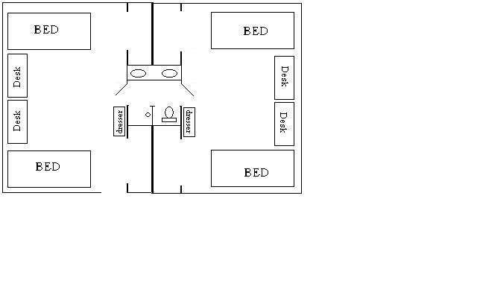
Room dimensions

Wallingford Hall – First Year Men’s Hall
XL Twin Mattress
Room Dimension: 16' x 10'
Window: 9' x 4'11"
Closet: 3'8" x 8"
Bed: 38.5 x 83 inches, space below the bed is 30 inches

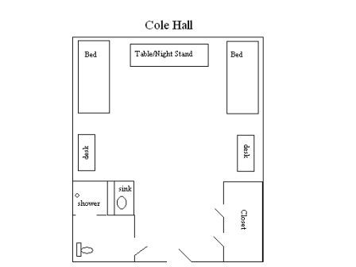
Cole Hall – First Year Women’s Hall
XL Twin Mattress
Bed: 38.5 x 83 inches, space below the bed is 20 inches
Window: 3’11’’ tall 4’8’’ wide, Floor to windowsill - 39 inches
Ceiling: 10ft in bedroom, 7’6’’ in entry and bath
Closets: There are two closets, one has a mirror.
Each closet is 42inches wide and 90 inches tall (the clothing rod is at 62inches tall and there is a shelf above the rod). Each has a built-in shoe rack in the bottom of the closet it is 24’’ wide x 18’’ tall.
Room Dimension: (Front door to the window wall) 21’/end of bathroom/closet to the window wall 16’
East to West wall is 14 feet

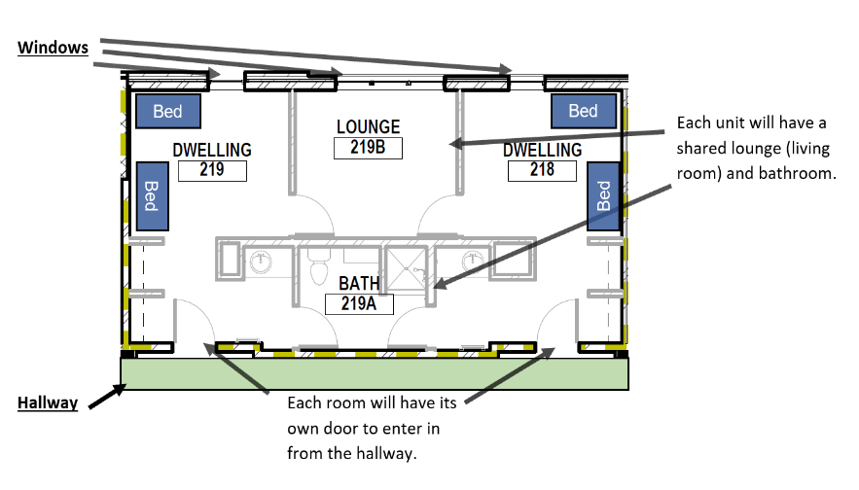
Winfield Hall – Upperclassmen Co-ed/Optional for First Year Honors Students
XL Twin Mattress
Bed Room Dimension: 11'6" x 10'3"
Living Room Dimension: 12' x 10'2.5"
Closet: 3'2" Wide
Bed: 38.5 x 83 inches, space below the bed is
Note: This is the only residence hall with bed-lofting and bunking ability

What to Bring
Items we consider essential are starred (*). Make sure to consult your roommate to avoid purchasing doubles of items like lamps or appliances!

Bed and Bath
□ Mattress Pad (XL twin)*
□ Pillow(s) and Pillow Cases *
□ Extra-Long Twin Sheets *
□ Comforter/Blankets *
□ Towels and Washcloths *
□ Throw Rugs
□ Desk Lamp & Bulbs (non-halogen)
□ Floor Lamp & Bulbs (non-halogen)
□ Hangers
□ Trash Can/Trash Can Liners
□ Microwave (1000 watts or less)
□ Compact Refrigerator (4.5 cu ft or less)

Identification/Money
□ ATM Card *
□ Credit Cards *
□ Drivers License *
□ Insurance Cards *
□ Passport/Visa
□ Social Security Card

Hygiene Supplies
□ Cleaning Supplies*
□ Ear Plugs
□ First Aid Kit
□ Prescription Medications *
Personal Hygiene Products/Toiletries *
□ Soap/Shampoo
□ Hair Products/Hair Dryer
□ Makeup/Moisturizers
□ Toothbrush/Toothpaste
□ Shaving Accessories

Electronics
□ Cell Phone & Charger
□ Gaming System
□ Power Strip w/Surge Protector (UL rated)
□ TV

Laundry Supplies
□ Laundry Detergent *
□ Dryer Sheets
□ Drying Rack
□ Fabric Softener
□ Iron (auto shut-off)/ Ironing Board
□ Laundry Bag/Basket

Miscellaneous
□ Backpack
School Supplies
□ Pens/Pencils □ Scissors/Stapler
□ Spiral Notebooks □ Tape/Post-its
□ Calculator
□ Calendar
□ Message Board (Dry erase board)
□ Plastic Food Storage containers
□ Dishware/Silverware
□ Can Opener
□ Water Filter Pitcher
□ Umbrella/Raingear
□ Fan (large and/or clip)
□ Tacks – (DO NOT USE 3M™ Adhesive Products

