Professional Communication
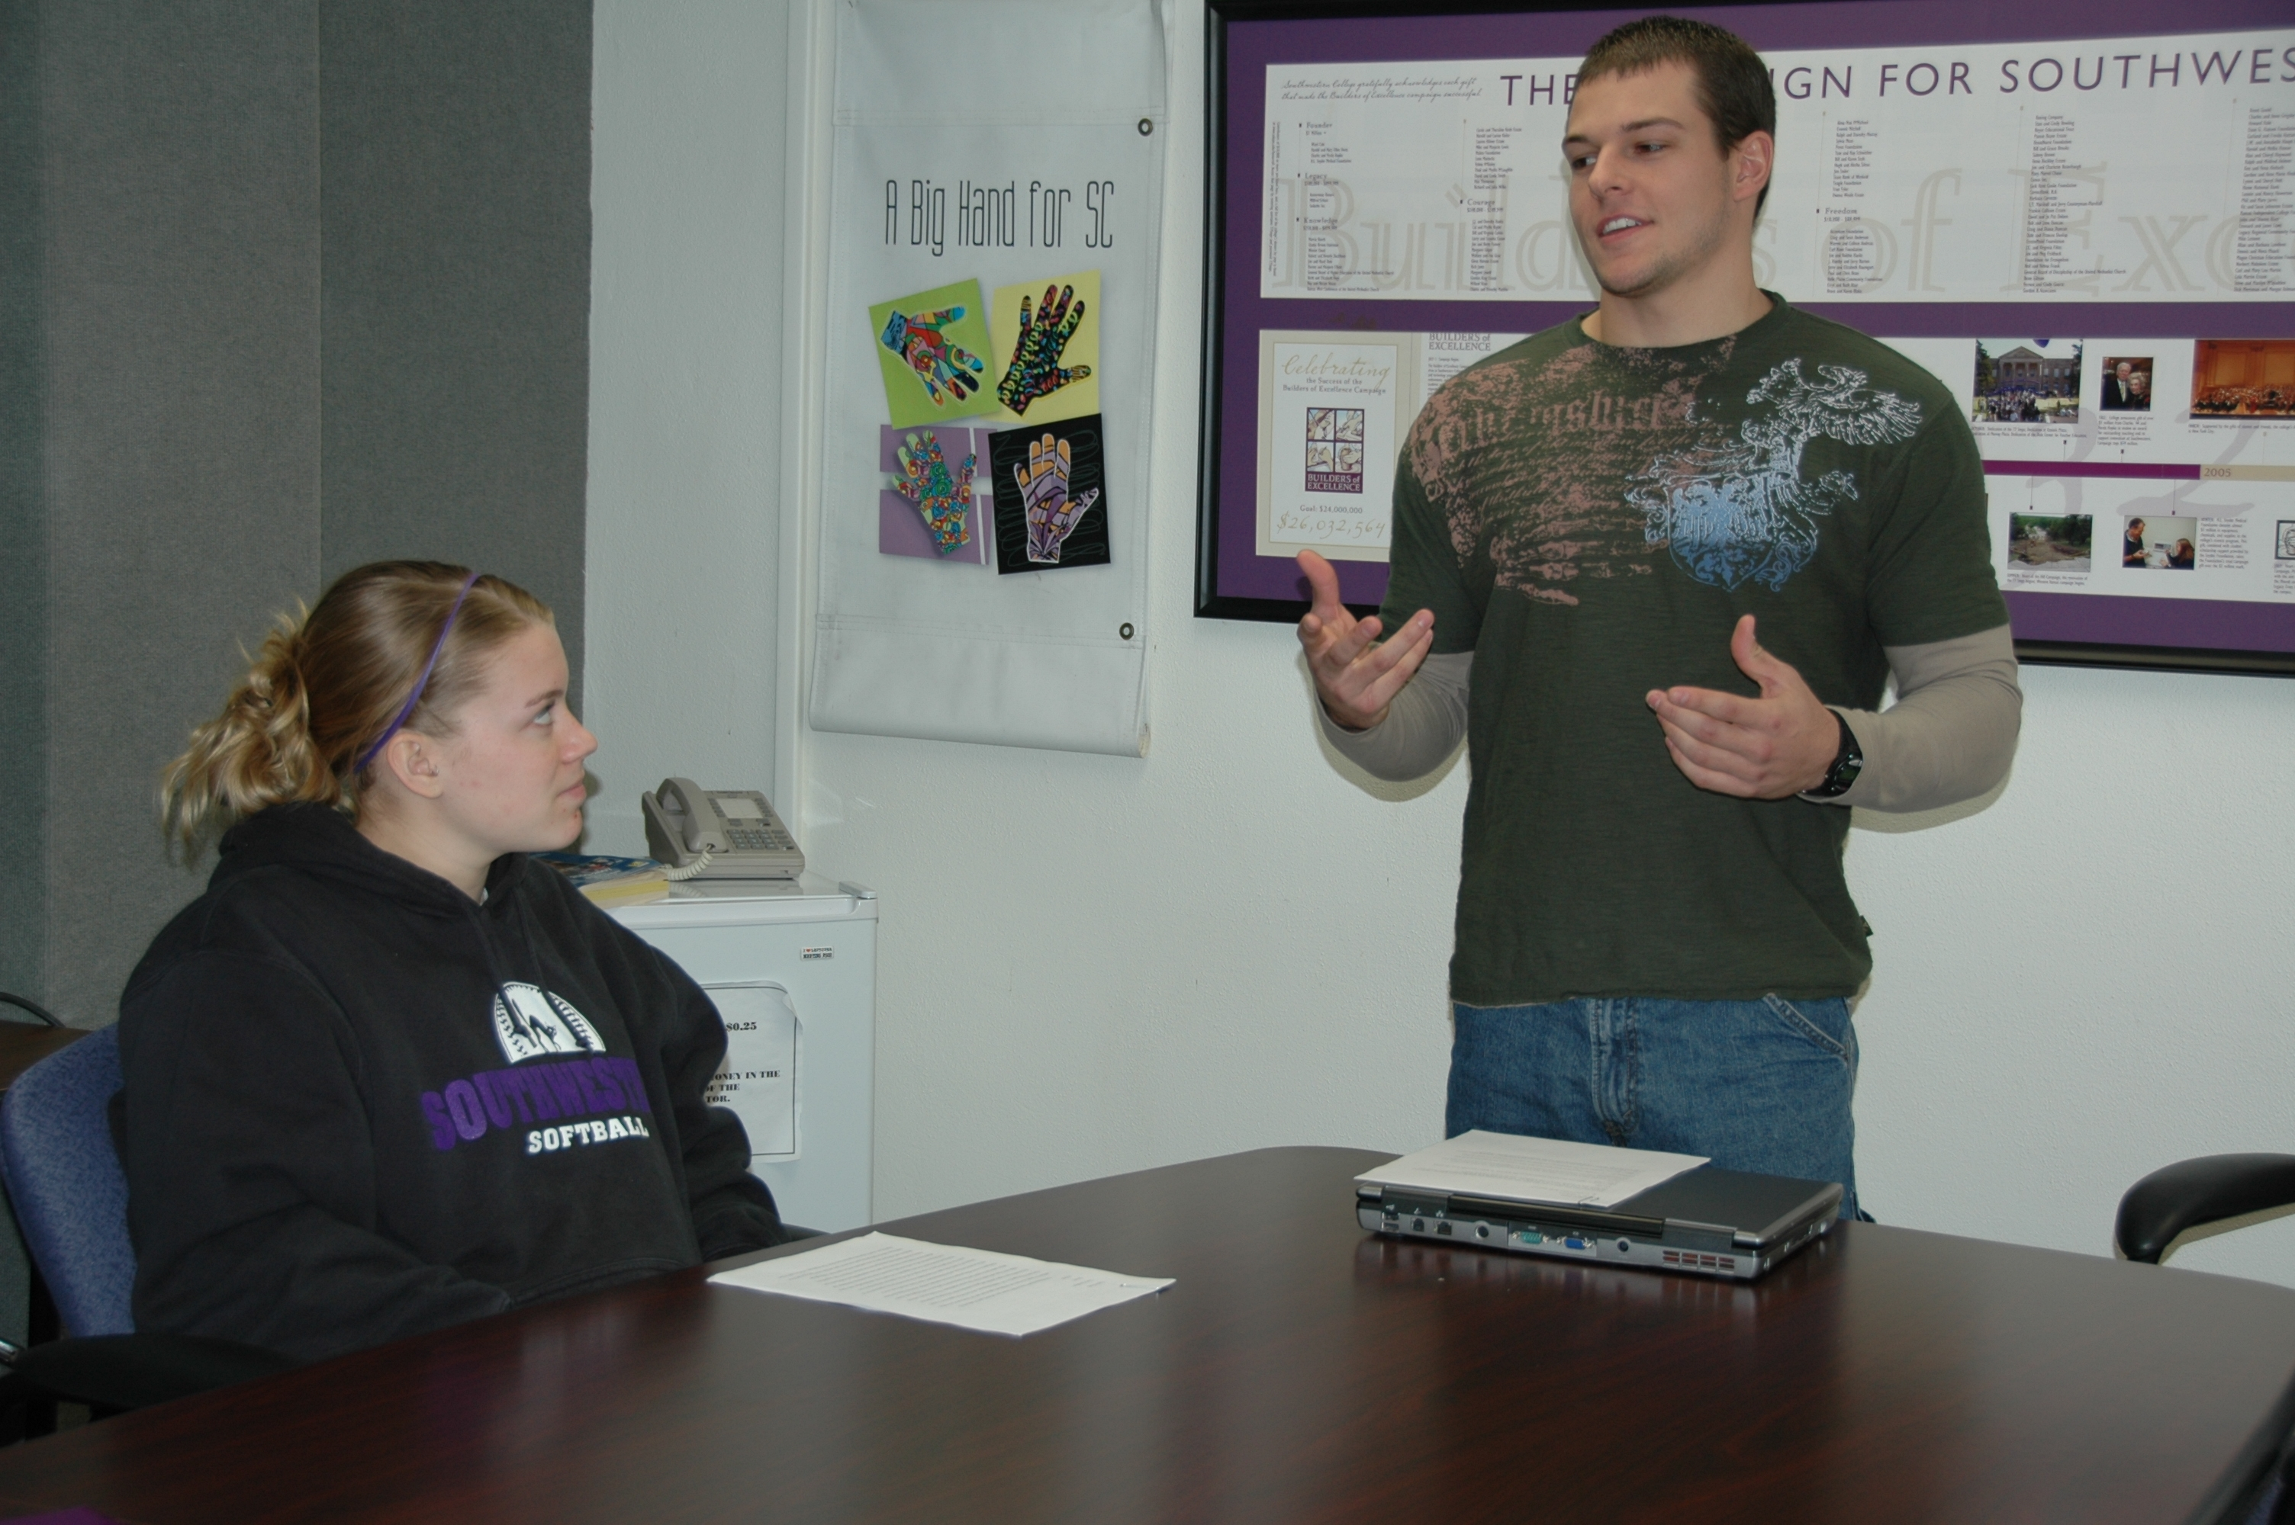

Cox Cable:
Our interns enjoy many opportunities to receive leading-edge training and valuable hands-on experience, and get an inside track for career development at Cox. Opportunities for interning with Cox are generally in the areas of information technology, marketing, engineering, public affairs and human resources.
http://www.cox.com/CoxCareer/career_intern.asp

EServer TC Library:
Internships help students develop writing portfolios and learn professional work attitudes, while building relationships with potential future employers and establishing professional contacts.
http://tc.eserver.org/dir/Internships

nps.gov:
Further your public speaking abilities by presenting programs to individuals, schools or groups (Park Ranger Intern, Education Intern, Public Affairs Intern) that reveal the meaning of our natural and cultural resources, or work with individuals or groups who are volunteering to protect the resources in the park (Volunteer Management Intern).
http://www.nps.gov/samo/parkmgmt/communicationinternships.htm

Kennesaw State University:
Non-Profit Internships
http://www.kennesaw.edu/communication/nonprofitinternships.shtml

Communication Internship Finder:
To help the organization to develop a new newsletter to communicate with stakeholders the ongoing activities. To assist the organization with creating a brochure highlighting the functions of the Dream Center. To work with the organizations website, helping to make necessary changes and jumpstart social media sites.
http://socinternships.blogspot.com/

Chicago Internship Finder:
Walker Sands Communications is looking for an energetic detailed-oriented person to serve as a public relations intern for a 13-week summer 2010 internship at its Chicago office.
http://www.walkersands.com/Chicago-PR-Summer-Internships.htm

Health Communication:
The HCIP gives highly qualified graduate students and recent graduate school graduates the opportunity to participate in vital health and science communications projects in one of the many offices that make up the NCI. Interns will select an area of emphasis: health communications or science writing. Six-month and one-year internship terms are offered.
https://hcip.nci.nih.gov/

Children’s Defense:
About 70 undergraduate, graduate and recent graduates intern in the CDF Washington, D.C. office each year and while a few of the internships give preference to certain majors everyone with a strong interest in child advocacy is encouraged to apply. CDF interns gain knowledge, skills, and experience for a lifetime commitment as a child advocate and public policy leader. They also get an insider's view of non-profit advocacy. Additionally, former interns stay active in CDF's mission through the CDF Intern Alumni Action Network. Our state and regional offices also offer internships. Interested individuals should contact each office directly for more information
http://www.childrensdefense.org/get-involved/internship-program/types-of-internships/communications.html

